Transportation Disadvantaged (TD) Public Workshop Summary
Palm Beach TPA, 301 Datura St, West Palm Beach, FL
February 23, 2022

Public Workshop Overview
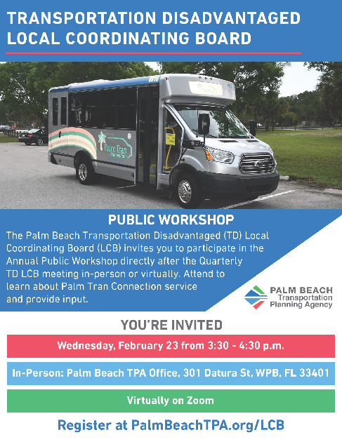
The Palm Beach Transportation Planning Agency (TPA) serves as the official Designated Official Planning Agency (DOPA) for Palm Beach County and is required by the Florida Commission for the Transportation Disadvantaged (CTD) to host an Annual Public Workshop for the Transportation Disadvantaged (TD).

This year, the workshop was held on February 23, 2022, immediately following to the scheduled quarterly TD Local Coordinating Board (LCB) meeting. The TPA organized the public workshop with the assistance of Palm Tran, the Community Transportation Coordinator (CTC) and provider of TD service in Palm Beach County.

The TD Public Workshop aimed to gather input on TD service in Palm Beach County and facilitate knowledge transfer and a thorough understanding of the paratransit system for all LCB members and attendees. The workshop consisted of brief presentation by TPA staff followed by an opportunity for public comment, which included a facilitated discussion by TPA and Palm Tran staff to provide information and collect feedback.

Presentation
The presentation included an overview of the TD Program, the CTC, and Palm Tran, as shown in Appendix A.

Attendees
The TD Workshop had a total of 26 participants. These included 12 LCB Members, 9 members from the public/other agencies, 4 TPA staff, and 1 Palm Tran staff as listed below and as shown in Appendix B.

Workshop Participants
- Mayor Steven Grant – LCB Chair, City of Boynton Beach, Florida
- Uyen Dang – Citizen Advocate
- Robert Goodman – Representative for the Disabled
- Vanessa Palomino – Area Agency on Aging
- Jerome Hill – FL Agency for Healthcare Administration
- Elizabeth Clark – Children at Risk
- Jodie Boisvert – Department of Community Services
- James Bonfiglio – Representative for the Elderly
- Marie Dorismond – Florida Department of Transportation
- Laura Schultze – School District of Palm Beach County
- Angela Choice – Department of Veterans’ Affairs
- Milory Senat – Agency for Persons with Disabilities
- Vice Mayor Chelsea Reed – City of Palm Beach Gardens, Florida
- Jean Malacko – Family Care Council
- Krystal Logan – First Transit
- Stacy Jackson – First Transit
- Joanna Peluso – Healthier Jupiter
- CS – General Public
- Cesar Rued – General Public
- Natasha Villalba-Cruz – General Public
- Sue Davis-Killian – General Public
- Alyssa Frank – TPA Staff
- Margarita Pierce – TPA Staff
- Cassidy Sparks – TPA Staff
- Amanda Williams – TPA Staff
- Ron Jones – Palm Tran

Public Comments
The following questions and comments were collected during the workshop:

- Chair Grant commented on closing the Digital Divide experienced within the county and shared that it connects to transportation. For example, if someone can work from home, then it lowers the number of trips they would need to take via Palm Tran Connection.
- The fare for Palm Tran is $3.50. Although that amount may seem small, it can add up quickly for a family facing poverty. Is it possible to move to a sliding scale model instead?
  - Question answered by Palm Tran staff.
- Is the only option to purchase a Palm Tran Pass to go to the office in the Southern part of the county?
  - Question answered by Palm Tran staff.
- The addition of scheduling through the website has been helpful in scheduling. However, why has the number of days to book in advance changed from four days to three?
  - Question answered by Palm Tran staff.
- How will changes to the recertification process impact rider experience?
  - Question answered by Palm Tran staff.
- Member discussion ensued on fixed route locations in front of every high school, and transportation being the third highest barrier to employment.
- Palm Tran Connection helps provide mobility for citizens with disabilities and the drivers provide great service.

